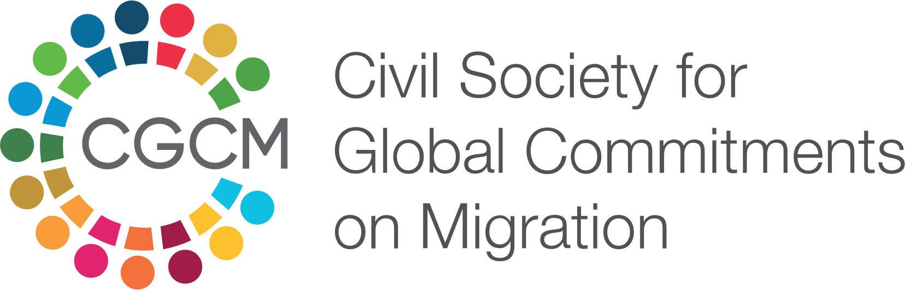

3 proposals for GFMD 2020 Regional Consultations on Bali Process

The call for a practice based approach in migration and development to promote practice, performance and actual impacts— not just aspirations and principles— have been well documented in the GCM process.
Based on that approach, the Civil Society for Global Commitments on Migration (CGCM) highlights some practice-based proposals for Bangladesh government to highlight at the GFMD 2020 Regional Consultations on Bali Process to be held on 29 June 2020.
The six GFMD 2020 Regional Consultation Thematic Notes provide a very comprehensive and aptly concise context on each of the thematic sessions. The proposals on this civil society note needs to be read in the context highlighted in those thematic papers.
Since each state will be allowed to have two participants in the breakout sessions, allowing them to contribute to two of the three breakout sessions in parallel, this proposal took into account only two of the three themes—
Theme 3: Leveraging technology to empower migrants
Theme 4: Addressing gaps in migrant protection
Proposals for Theme 3: Leveraging technology to empower migrants

A tripartite partnership for humanizing blockchain-based remittance platform

The blockchain can make remittance faster and cheaper by removing the traditional intermediaries in cross-border money transfers. The recently drafted National Blockchain Strategy of Bangladesh highlights remittance and some after arrival services as potential sectors where blockchain technology can play a crucial role for migrants. Meanwhile, Bank Asia has teamed up with UAE’s RAK Bank to channel remittance through blockchain.
Proposal: A tripartite partnership among government, IT industry and civil society will be essential for financial inclusion of the unbanked and underbanked migrants through blockchain.
Governments in both remittance receiving and sending countries need to review existing Anti-Money Laundering and Counter Terrorism Financing regulations to reduce legal bottlenecks to blockchain’s expansion; IT industries need to work on ensuring last-mile access to this service; while civil society, based on their experience of working for the migrants, can help humanizing the service.

Basic interoperability standards for data sharing and protection

While migrants database remains one of the most discussed and least implemented global commitments on migration, the GCM and regional consultative processes continue to highlight the need for database to ensure informed and accountable migration process. There have also been sporadic initiatives at the national-level to connect various ICT-based information services for aspirant and returnee migrants, although interoperability remains a major challenge in this regard.
Proposal: Member countries must adapt and enforce basic interoperability standards for data sharing and protections.
This will encourage public and private initiatives to safeguard the privacy and protection of migrants data, while at the same time, prepare the existing IT-initiatives and databases to have reusability, accessibility and database-integration capabilities for any future global or regional initiatives.

Proposals for Theme 4: Addressing gaps in migrant protection

Compact of sending countries to address wage theft and other gaps in migrant protection

Migrants have long been the victims of wage theft by employers through illegal deductions and denial of overtime, minimum wage and even full wage. However, the Covid-19 pandemic and ensuing recession has accelerated wage theft as renowned global brands declining to pay workers while migrants in destination countries are being forced to take unpaid leave, reduced wages, or are being evicted without pay. Hence, migrants rights and labor organizations are seeking justice for repatriated workers.
Proposal: Compact of sending countries to address wage theft and other gaps in migrant protection which escalated due to COvid-19 pandemic
Migrant protection—from ethical recruitment to wage-protection– can be ensured if the labor-sending countries come to an agreement on common margin of pay and job standards. The recent legislation by Victorian Legislative Council making wage theft a criminal offence in Australia can be promoted as an example by the migrant sending countries to ensure that migrant workers are covered by such legal mechanisms in the destination countries.

About CGCM
CGCM (Civil Society for Global Commitments on Migration) is a collective action for supporting the implementation, follow-up and review of the global commitments on migration. The aim of CGCM is to increase CSO monitoring of the global, regional and intra-regional cooperation and commitments on migration and development. Currently 18 of the leading CSOs and Tus who work of migrants and workers rights in Bangladesh are members of CGCM. See more here: www.thecgcm.org/news
IID is the Secretariat of CGCM. Contact: cgcm.sec@gmail.com

Faal, G. 2017. Overprincipled and Underperforming: Why We Need a Practice-based Global Compact on Migration. https://publications.iom.int/books/overprincipled-and-underperforming-why-we-need-practice-based-global-compact-migration
The opening plenary took place on 15 June 2020, while the breakout session that allows intervention will take place on 29 June 2020.
For instance, regional initiatives such as the Regional Biometric Data Exchange Solution (RBDES) offered Bali Process members to share biometric data.
BMET initiated a database project before, and Bangladesh has been collecting basic information of returnee migrants at the airport during the pandemic.
For instance, A2i, ILO and IOM initiated consultations to bring together existing ICT-based complaint mechanisms for migrants and conducted mapping and scoping of services for migrant workers.
CNN. 22 April 2020. Bangladeshi garment workers face ruin as global brands ditch clothing contracts amid coronavirus pandemic.
Human Rights Watch. 2 June 2020. Ensure Justice for Migrant Workers Sent Home
The demand for a compact of sending countries was highlighted at a regional consultation of CSOs and MPs in Dhaka. URL: http://iidbd.org/p13858/
Wage Theft Bill 2020 at https://www.parliament.vic.gov.au/component/jdownloads/download/36-research-papers/13958-wage-theft-bill-2020

